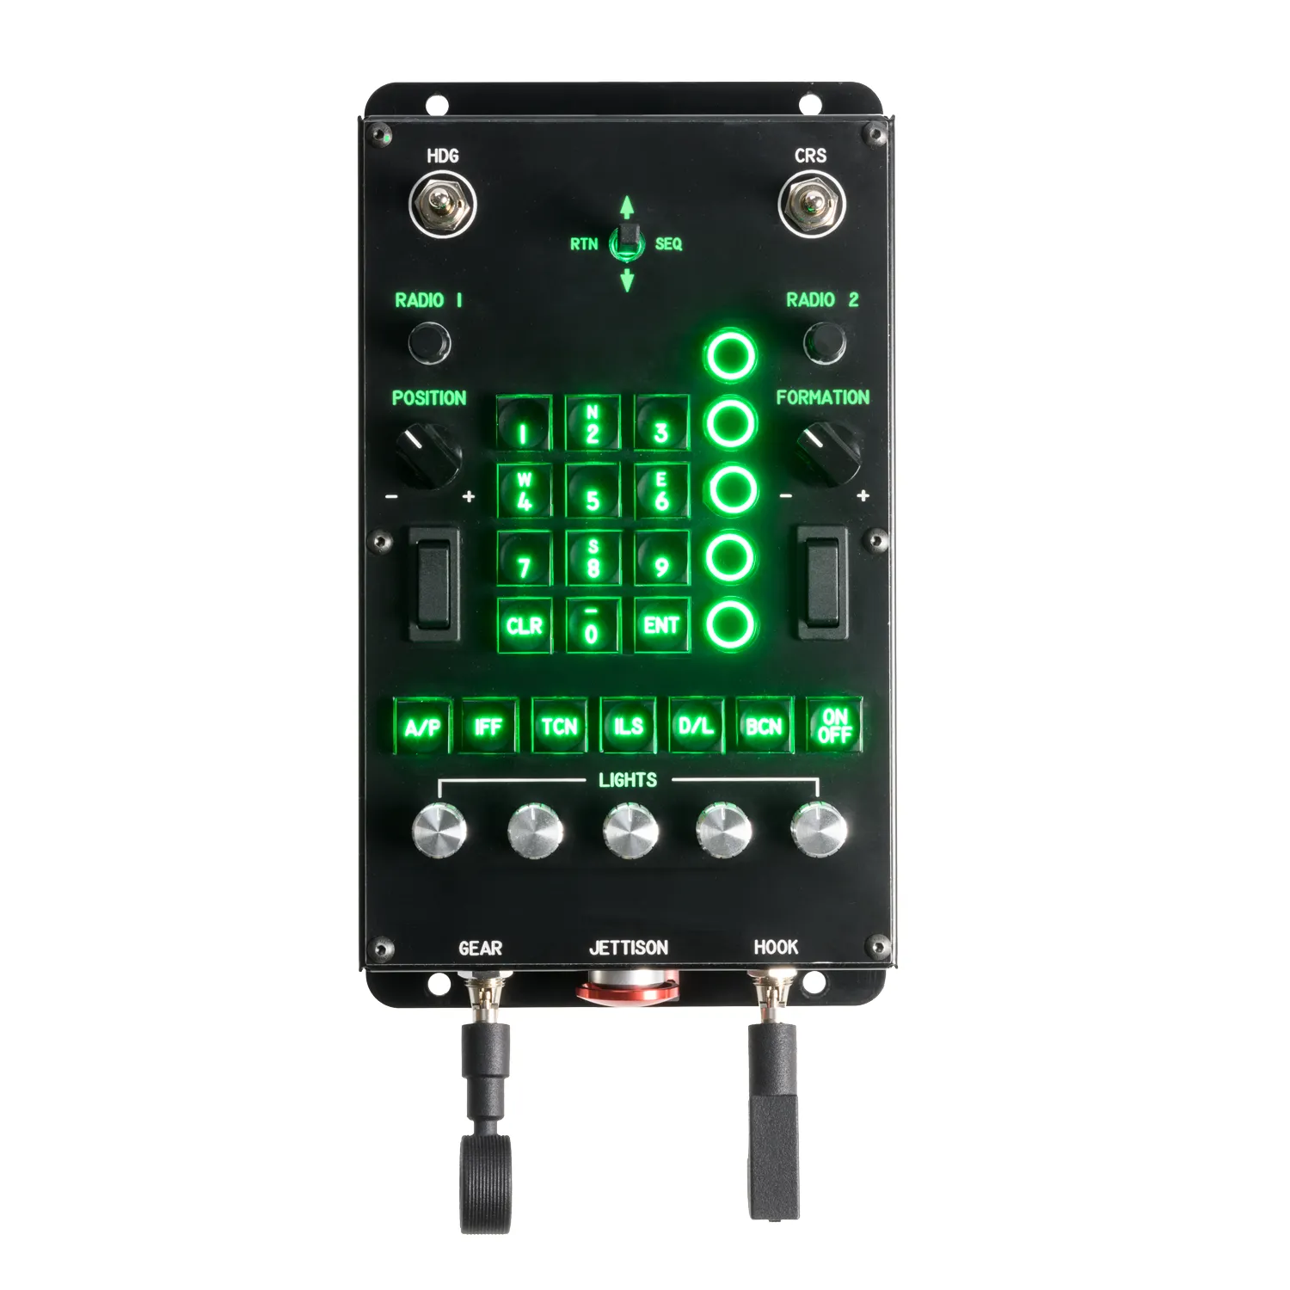
105 - Controls – Multifunction Button Box
U=Up, D=Down, N=Neutral, F=Forward, B=Backward, L=Left, R=Right, P=Press, S-*=Shift-*, L-*=Long-*

HDG Momentary Switch
- L: Altimeter Course
- R: --
CRS Momentary Switch
- L: Altimeter Fine
- R: --
Dobber Switch -- RB-05
- U: Pitch up
- D: Pitch Dn
- L/RTN: Left
- R/SEQ: Right
- P: --
Radio 1 Encoder -- CK-37 Mode Dial
- CCW: --
- CW: --
- P: Toggle In/Out
Radio 2 Encoder -- Weapon Select Dial
- CCW: --
- CW: --
- P: --
Numpad
- CLR: LS
- ENT: L MAL
Position Knob (left side): Position
Formation Knob (right side): Formation
UFS Option Pushbuttons
- Alt Hold
- Att Hold
- --
- --
- --
Left Rocker: Ldg/Taxi lights
Right Rocker: --
Mode Buttons:
- A/P: --
- IFF: --
- TCN: --
- ILS: --
- D/L: --
- BCN: --
- On/Off: --

Lights Knobs
- Anticollision
- Flood
- Instruments
- Consoles
- --
Gear Switch: Gear
Hook Switch: Reverse (up = active)
Jettison Button: Jettison Weapons

(to adjust lights, hold A/P and TCN and turn the Radio 2 Encoder)

